AS IS – GA Service FKD

Document Information
File Name | AS IS – GA Service FKD

Change Records
Date | Author | Version | Change Reference
14-04-2025 | Nurhidayanto | 1.0
 | Ambar Kusuma | 1.0

Reviewer

Name | Position
Imam Yogi | Section Head
Table of contents
1 Objective/Scope 3
1.1 Objective 3
1.2 Scope 3
1.3 Flowchart 3
2 AS IS Business Process Flow & Process explanation 4
2.1 Business Flow 4
2.1 BUSINESS FLOW …………………………………………………………………………………………………………………………………………4
3 ISSUE 3
4 Approval 4

- Objective/Scope
  - Objective
Currently Users of Office Vehicle Facilities (FKD) still using internal application at SIMHOMEPAGE when they are going to service their vehicles often do not bring the Work Order (SPK) for their vehicle service, due to urgency and the FKD user not having time to go to the GA Location, while the workshop makes a service tax invoice issued at the time of service, causing the bill made by the workshop to be hampered due to the absence of an SPK and causing the FKD service bill with a tax invoice to approach the expiration date of its tax invoice.

  - Scope
The Scope of this document is to provides an overview of the current office vehicle service submission system with the obstacles and problems that often occur in PT. SIM/SIS

  - Flowchart

Flow chart shape is same as Auto shape in Word and Excel

- AS IS Business Process Flow & Process explanation
  - Business Flow

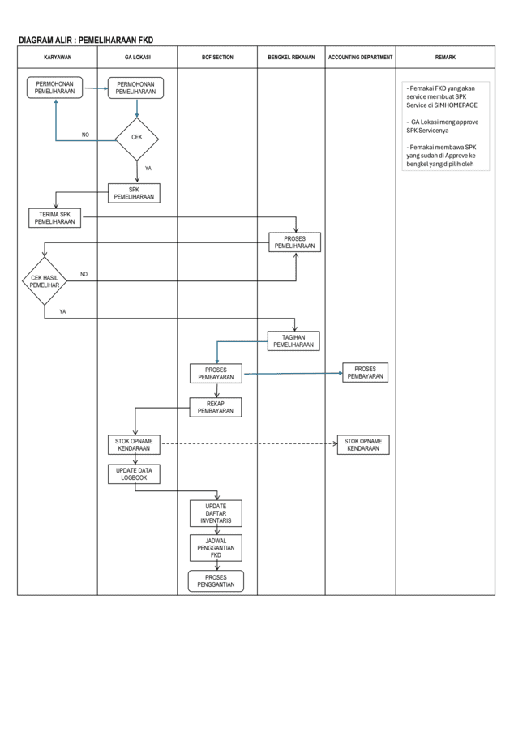

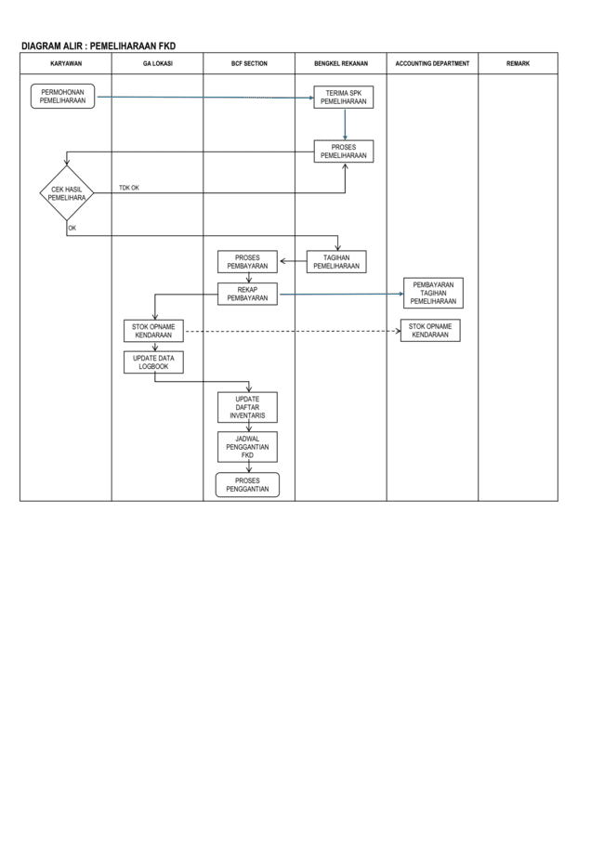

2.2 SIMHOMEPAGE SCREEN

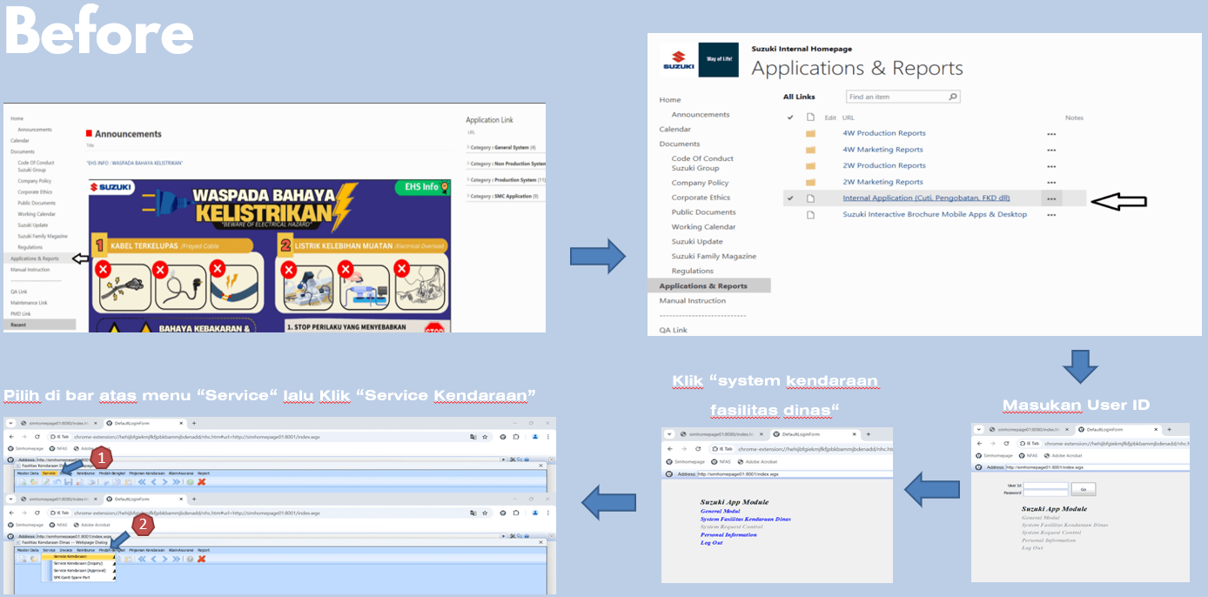

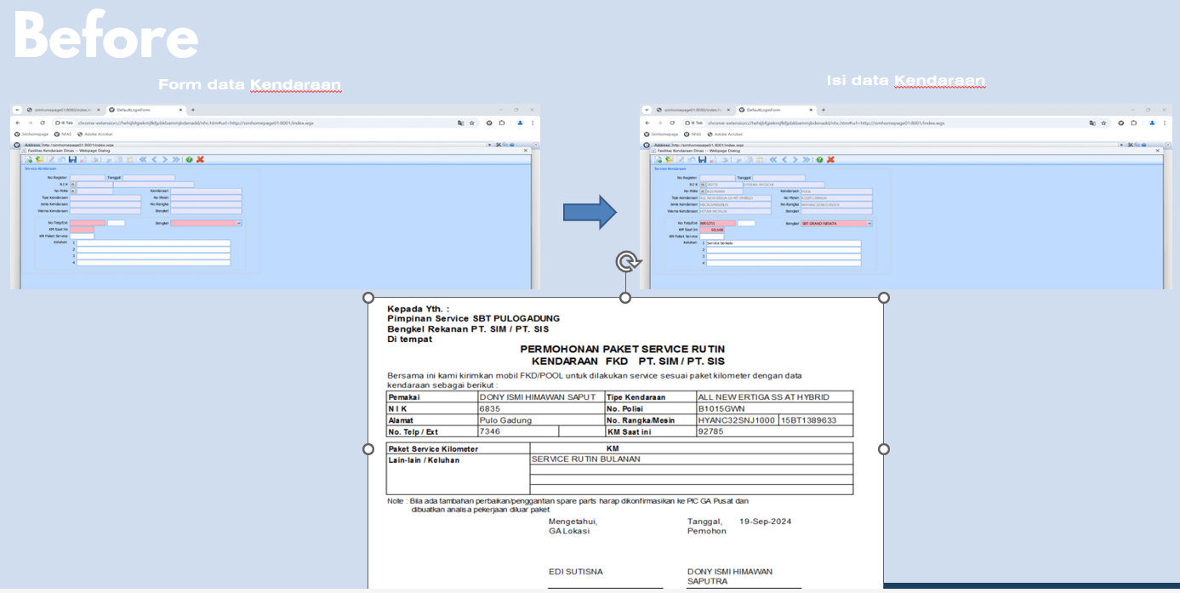

3. ISSUE

- Users sometimes don’t bring approval Work Order (SPK) form when car routine maintenance to the service workshop, causing delay for the FKD service billing processed and could impact to tax invoice expiration dated.
- Submission and approval of Work Order form (SPK) still using printed form and handwrite approval processed, causing cost on print consumables and time consuming.
- Users depend on manual scheduled for their car routine maintenance.

4. APPROVAL

After reviewing the as is business process analysis, we, agree to use this document.

User / Key User Department

Approval | Approval | Approval
Nurhidayanto  Staff GA BCF Section | Ambar Kusumaningayu  Staff GA BCF Section | Imam Yogi Wibowo  Staff GA BCF Section
Gunardi Prakosa
Dept. Head General Affair

IT Department

Approval
Novi Nirwanto | Mohamad Sofani |  | Krisna Raisandi
Staff IT Digital Improvement I Section | Staff IT Digital Improvement I Section |  | Section Head IT Digital Improvement I Section
 | Sugita Hitoshi
 | Dept.Head IT Department

